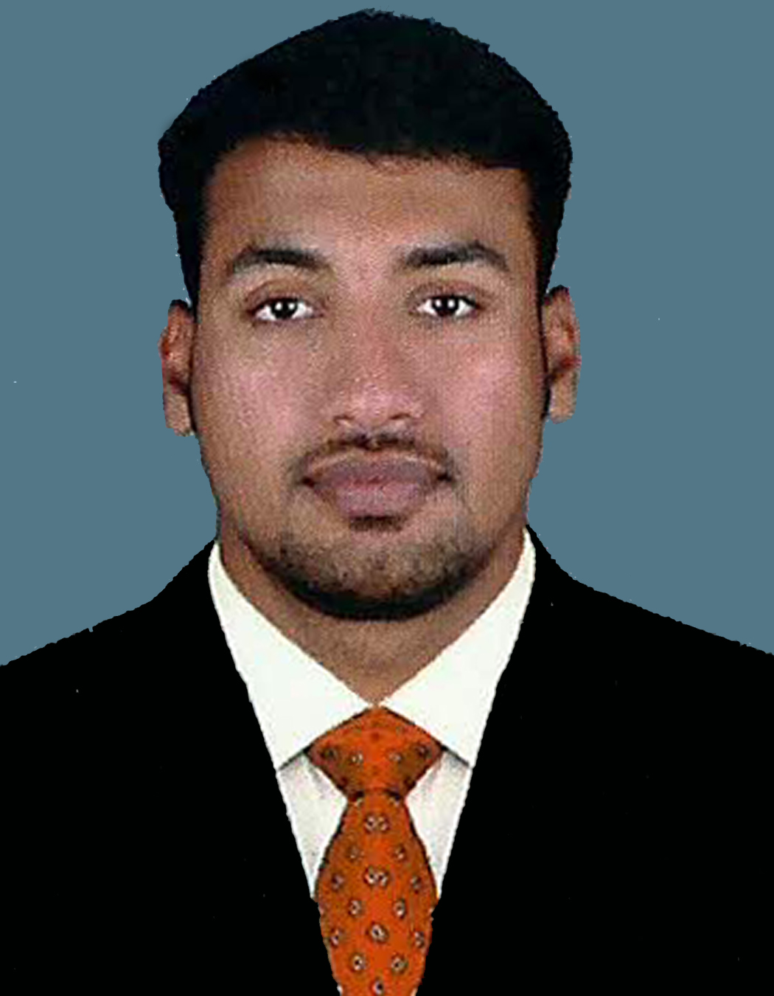
BIO – DATA

CAREER OBJECTIVE Passport No. G2220626
Seeking a position to utilize my skills and abilities in any section as mentioned, one which offers professional growth while being resourceful and innovative.
PERSONAL DETAILS
Name : SIJO JOSE K
Father’s Name : K.T.Jose
Address : Kangappadan house
Karuvannur .P.O
Puthenthodue
Kerala, Thrissur – 680711
Contact Number : 9645522548 (0480 – 2887388)
E-mail I D : sijojose86@yahoo.com
Date of Birth : 06-11-1986
Sex : Male
Religion : Christian
Cast : Roman Catholic
Nationality : Indian
EDUCATIONAL QUALIFICATION
- Passed Secondary School Leaving certificate (SSLC) with 60% Marks under Board of Education, Kerala, India. March 2002
- Office Secretary ship (VHSE) with 72% Marks
- Typewriting English (Higher)
- B.com (Income Tax) passed with 50% Marks
- Tally & Peachtree (Accounting Software)

(02)
WORK EXPERIENCE
- Working as Chief Marketing Manager in Designs And Technologies, Thrissur – Kerala (From 21-10-2013 To Still continuing)

- Working as Junior Officer (Current Account) in ICICI Bank Thrissur – Kerala (01-06-2011 To 07-10-2013)

- 2.5 years experience, working as an Accountant cum Estimator, Handling of Purchase and sales, Store Keeping & Office Administration in AL OLA Aluminum Co.L.L.C in Sharjah – UAE (01-08-2008 To 31-04-2011)

- 4 Year experience, working as an Accountant in Selmor Agencies, Trichur, Kereala, India

REFERENCES:

- Ramanathan Iyer (2) Pawsan Varghese,
Cluster Branch Manager AGM & Head Operations,
ICICI Bank Ltd – Thrissur ESAF Cooperative Ltd – Thrissur
Mob: 0091 9745001667 Mob: 0091 8589976111

(3) Rajesh A (4) Jaibee Vargheese
Thrissur West Fort branch Manager Branch Manager
ICICI Bank Ltd – Thrissur ICICI Bank Ltd - Angamally
Mob: 0091 8129310375 Mob: 0091 9746745642

(3)

LANGUAGE PROFICIENCY
- English
- Hindi
- Malayalam
OTHER ACHIEVEMENTS
- Achieving Good Student Award in School Level
- Prized Best Player in Cricket
PERSONAL STRENGTHS
- Optimism
- Confidence
- Adaptability
- Good interpersonal skills
- Good communication skills
SPECIAL INTERESETS
- Driving
- Music
DECLARATION
I do hereby declare that the above furnished statements are true to the best of my knowledge and belief

Place: Karuvannur,
Date: 04-08-2014 SIJO JOSE K

